

**Application Development for Mobile Devices (Comp1661)**

Course Work

**Phan Dinh Huy , GC60105**

Contents

1. App inventor PaintPot 1

2. App Inventor MoleMash 4

3. Investigation of “Android API level” 5

4. Exercise to add a button and Activity to the NameEntry App 5

5. Create an Android App to calculate overtime pay. 7

6. SQLite database exercise 10

• Add a record in the database 10

# App inventor PaintPot

* **Code**

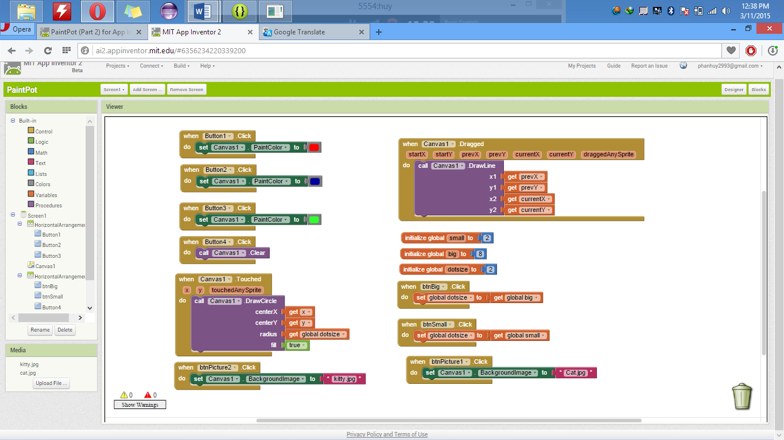

* **The application working**

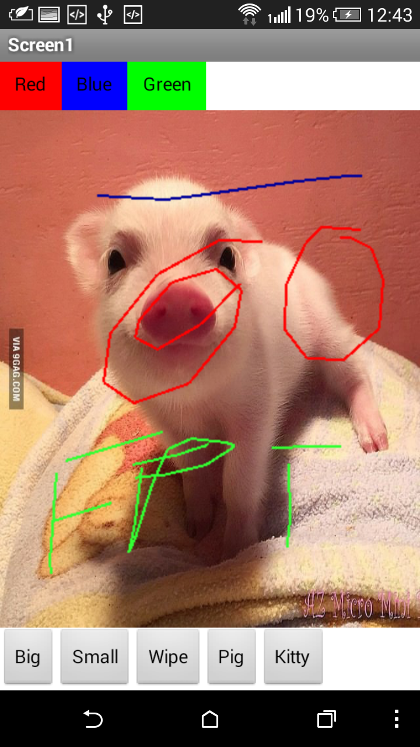



# App Inventor MoleMash

* Code

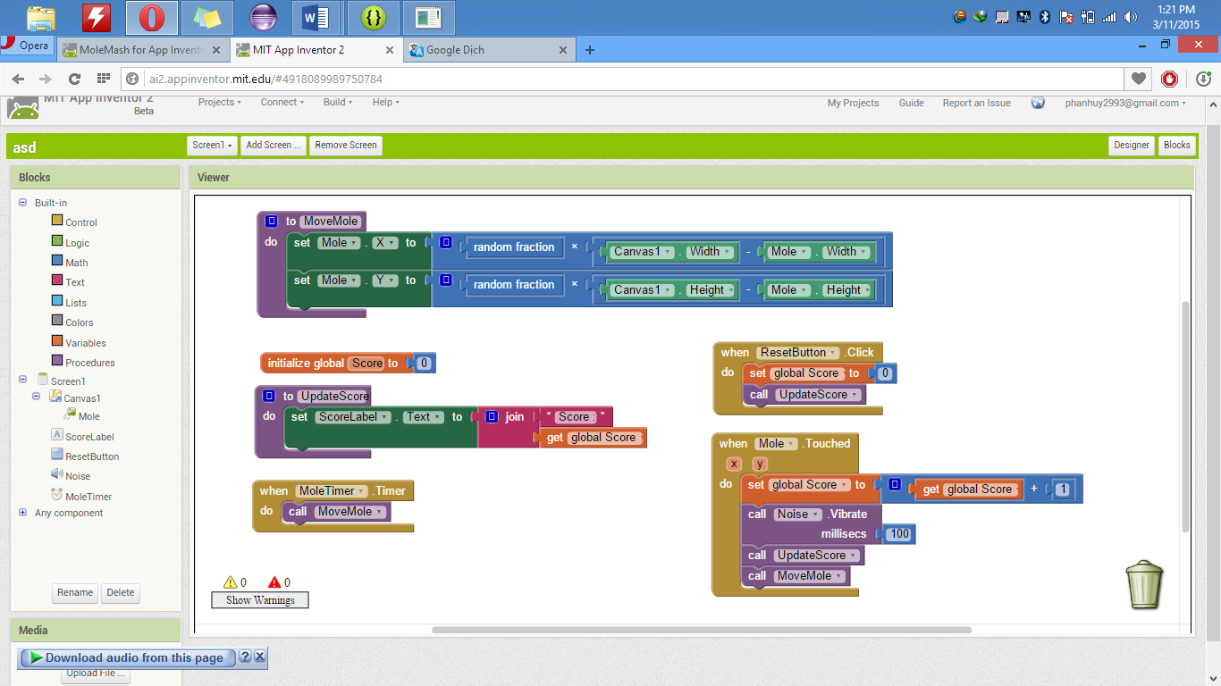

* The Application working

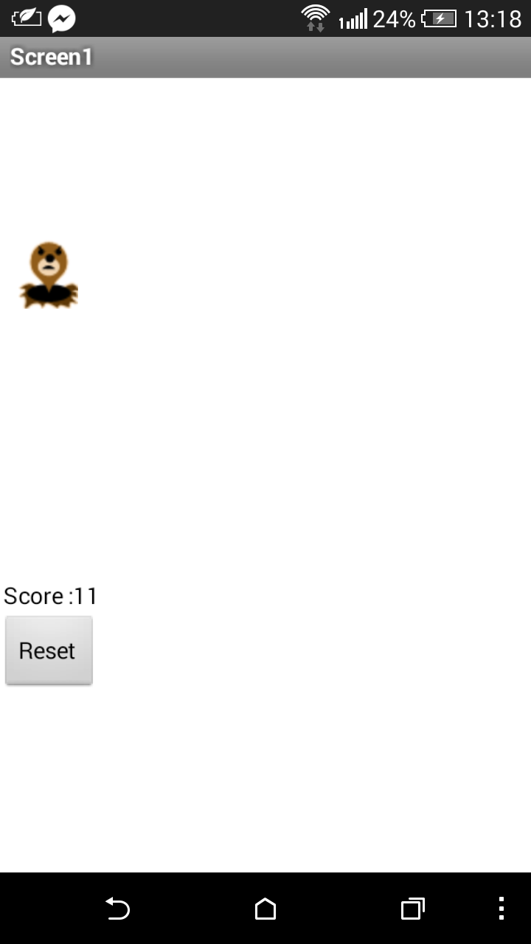

# Investigation of “Android API level”

API Level is an integer value that uniquely indentifies the framework API revision offered by a version of the Andorid platform. The framework API consists of:

* A set of XML elements and attributes for declaring a manifest file
* A set of XML elements and attributes for declaring and accessing resources
* A set of Intents
* A set of permissions that applications can request, as well as permission enforcements included in the system
* A core set of packages and classes

The API Level identifier serves a key role in ensuring the best possible experience for users and application developers:

* It lets the system negotiate the installation of applications on the user's device, such that version-incompatible applications are not installed.
* It lets applications describe the framework API revision that they require
* It lets the Android platform describe the maximum framework API revision that it supports

Each Android platform version stores its API Level identifier internally, in the Android system itself.

The Android platform is Google Inc.'s open and free software stack that includes an operating system, middleware and also key applications for use on mobile devices, including smartphones. Android is an Open Handset Alliance Project.

*(Source: Google)*

# Exercise to add a button and Activity to the NameEntry App

* Running app

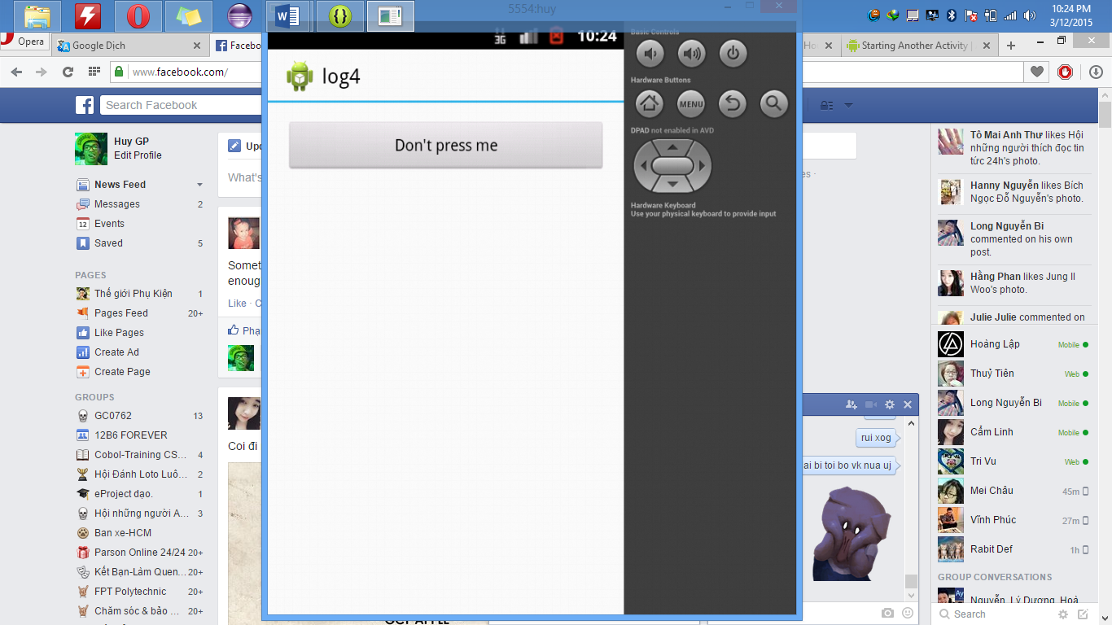

* When the button is pressed.

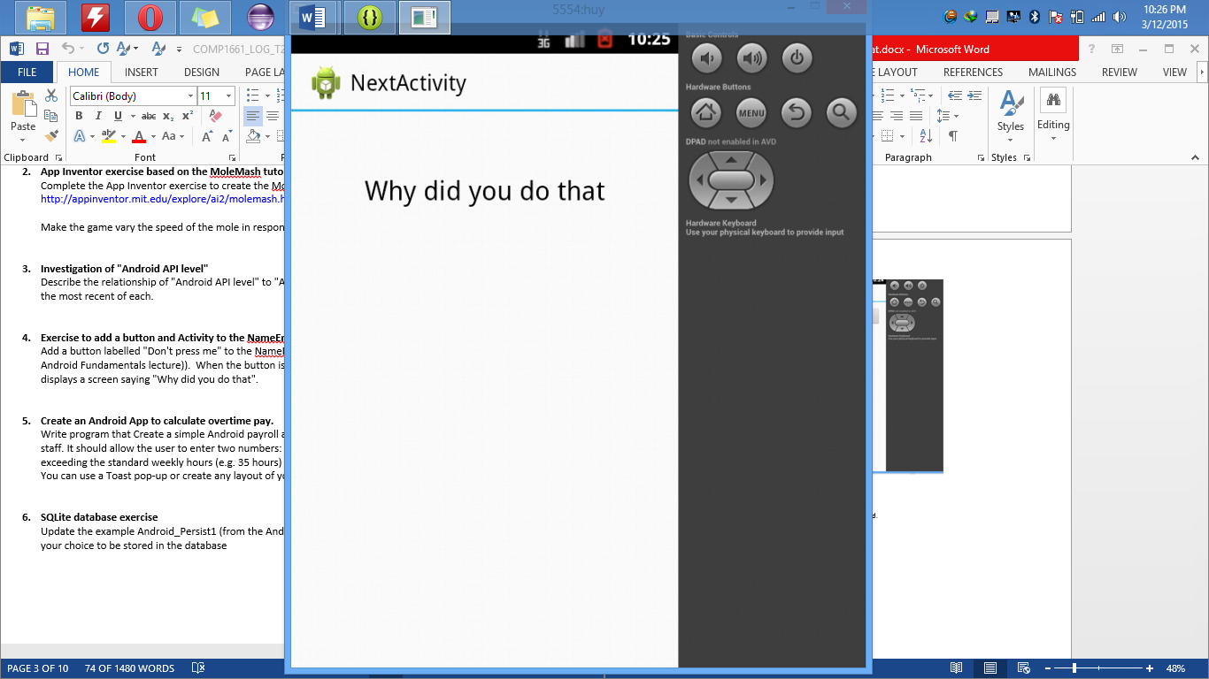

# Create an Android App to calculate overtime pay.

* Not overtime

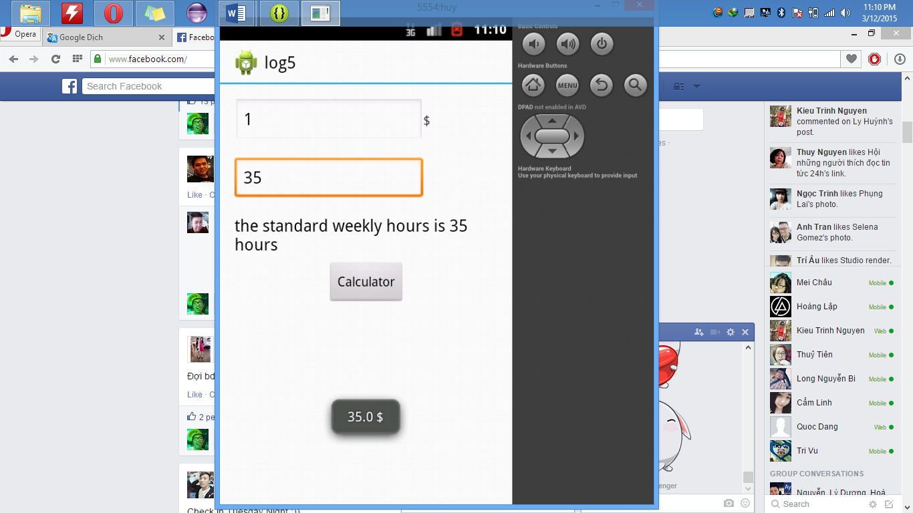

* Overtime

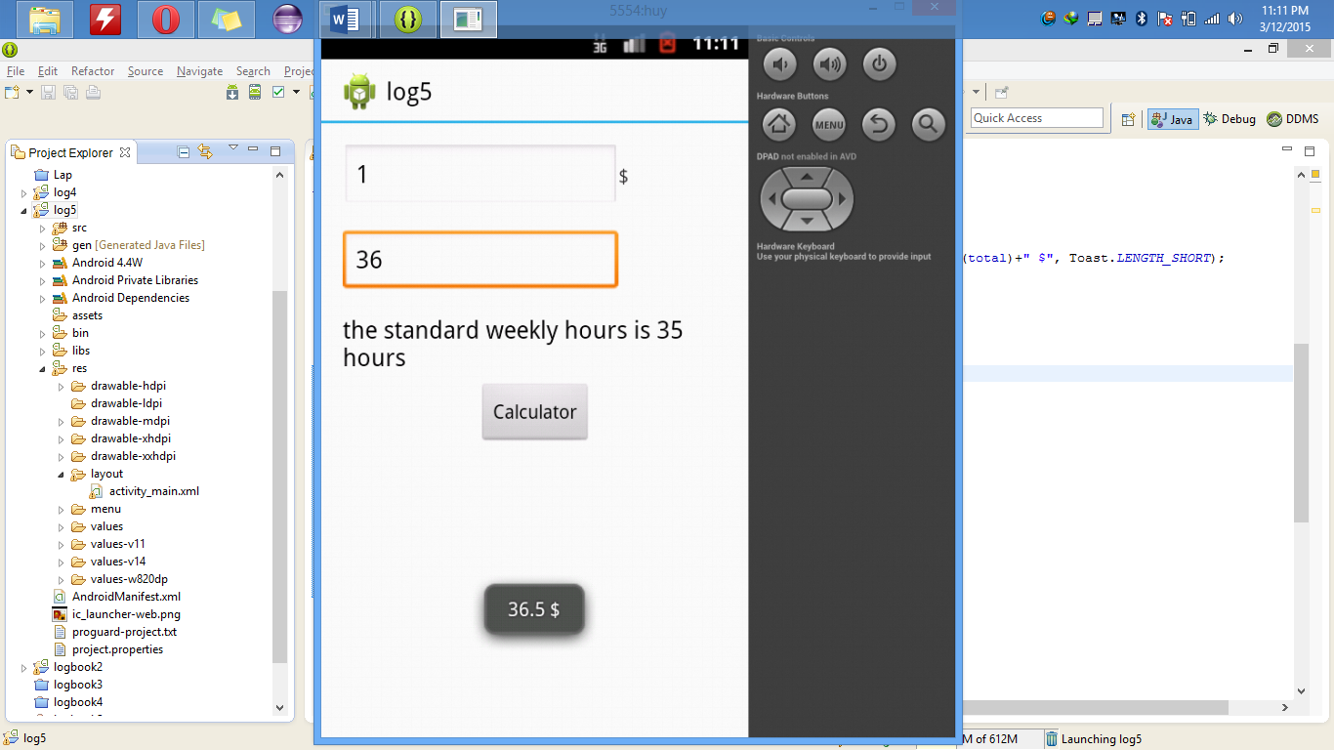

# SQLite database exercise

# Add a record in the database

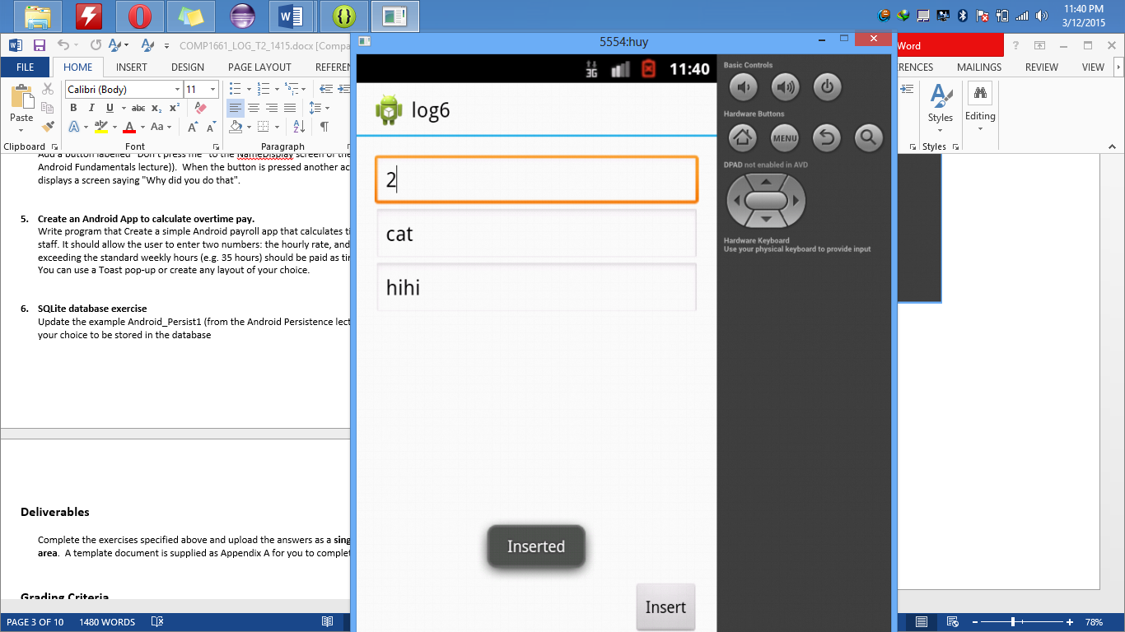

* Record has inserted

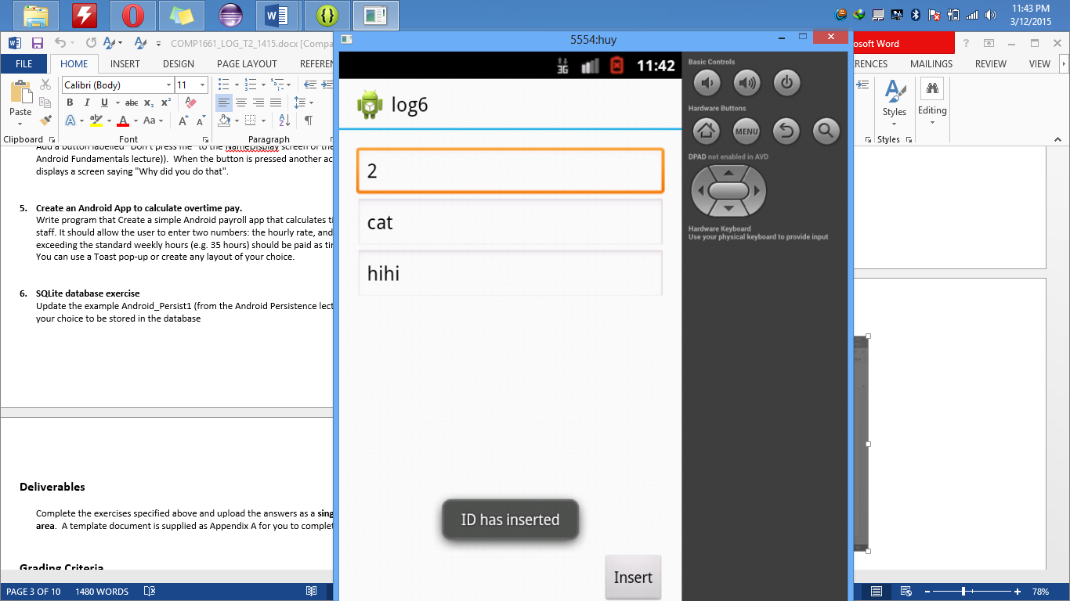s